

ECA 1401 – EMBEDDED SYSTEMS
EXPERIMENT 4 - 7 SEGMENT DISPLAY USING AT89C51 USING PROTEUS
Name: Janani R
Reg No: 192511067

Program:
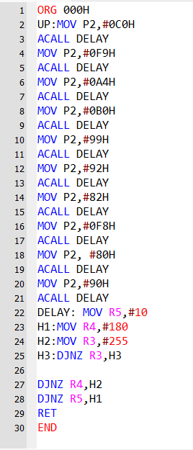

Output:
